Focus Adjunct

✅ What Is a Focus Adjunct?
# Source: AI Source: Provided by: [Data Path: Persons Table -> ID Column: 1, Name_En Column: Motasem Essam] -> From: [Chatgpt (GPT-4-turbo)] on [8/6/2025]
A focus adjunct is a word or phrase that highlights or limits the part of the sentence receiving special emphasis. It indicates what exactly is being focused on, often by showing contrast, addition, or restriction.
It answers questions like:
- Exactly what part?
- Who specifically?
- To what extent?
- Which one(s)?

🔸 Common Forms of Focus Adjuncts:
# Source: AI Source: Provided by: [Data Path: Persons Table -> ID Column: 1, Name_En Column: Motasem Essam] -> From: [Chatgpt (GPT-4-turbo)] on [8/6/2025]
- Single words: only, even, also, just, especially, mainly, particularly, alone
- Phrases: as well, not even, at least

🔸 Examples of Focus Adjuncts in Sentences:
# Source: AI Source: Provided by: [Data Path: Persons Table -> ID Column: 1, Name_En Column: Motasem Essam] -> From: [Chatgpt (GPT-4-turbo)] on [8/6/2025]
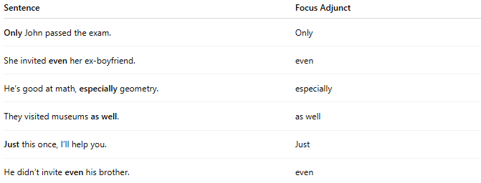
Sentence | Focus Adjunct
Only John passed the exam. | Only
She invited even her ex-boyfriend. | even
He’s good at math, especially geometry. | especially
They visited museums as well. | as well
Just this once, I’ll help you. | Just
He didn’t invite even his brother. | even

🔸 Position in the Sentence:
# Source: AI Source: Provided by: [Data Path: Persons Table -> ID Column: 1, Name_En Column: Motasem Essam] -> From: [Chatgpt (GPT-4-turbo)] on [8/6/2025]
- Initial: Even the teacher was surprised.
- Before focused element: She invited only her sister.
- After the main clause: He came along as well.
⚠️ Note: The position of focus adjuncts affects meaning and emphasis, so placement must be intentional.

🔸 Reminder:
# Source: AI Source: Provided by: [Data Path: Persons Table -> ID Column: 1, Name_En Column: Motasem Essam] -> From: [Chatgpt (GPT-4-turbo)] on [8/6/2025]
A focus adjunct adds clarity or emphasis to specific parts of the sentence, but it is not required for grammatical correctness.
🟢 "John passed."
🟡 "Only John passed." → Focus adjunct highlights exclusivity

